Tony Nguyen

Dr. Shawn Bowers

CPSC 324

26 February 2024

Homework 2

1. Step 1

a.

* Instead of “Compose a New Query,” it is now “Create SQL Query.”
* There is no “+” symbol to create a new query. It has been changed to “Query”.

b.

* Click “View actions” in the Explorer pane, then “Create dataset.”
  + 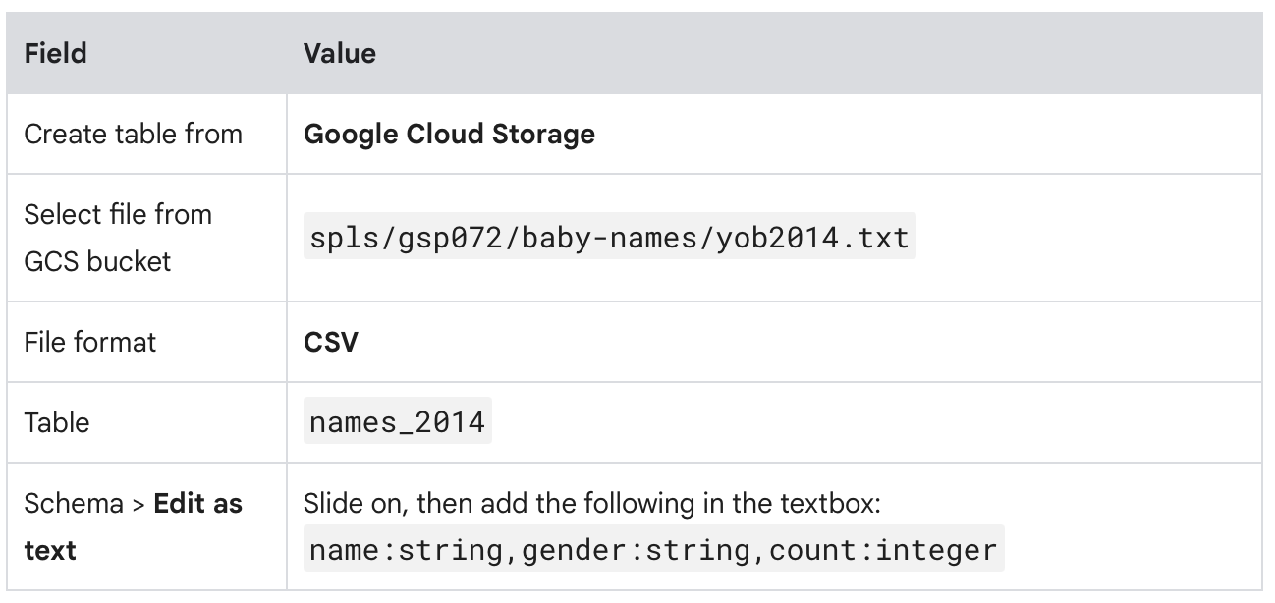
* Click “View actions” within the dataset, then “Create table.”

c.

* Query

SELECT

name, count

FROM

`babynames.names_2014`

WHERE

gender = 'F'

ORDER BY count ASC LIMIT 10;

* Result

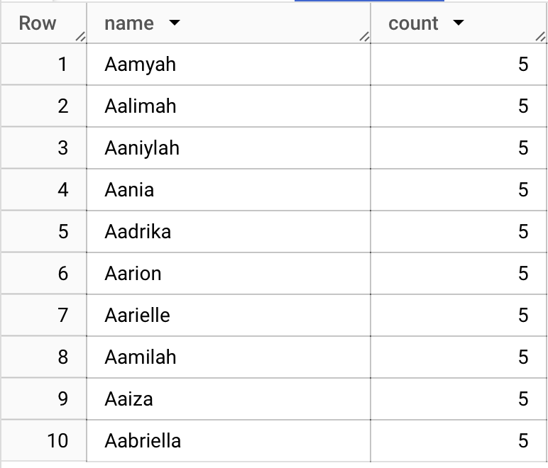

1. Step 2

* Examining
  + bq show bigquery-public-data:samples.shakespeare
* Listing datasets
  + bq ls
  + bq ls [Project ID]:
    - List the datasets in that specific project
    - Ending with a colon
* Creating
  + bq mk [Dataset Name]
  + bq keyword is used for dealing with the dataset level (think like a folder)
  + ls, normal command line args, deal with file level
  + unzip [filename]
  + Load a table
    - bq load babynames.names2010 yob2010.txt name:string,gender:string,count:integer
    - 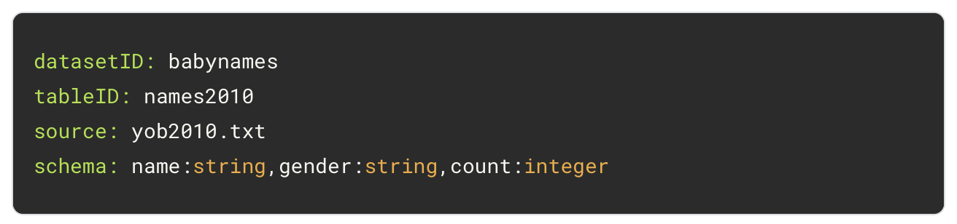
* Querying
  + bq query --use_legacy_sql=fals \ [SQL_CODE]
  + bq query “[SQL_CODE]”
* Removing
  + bq rm -r babynames
* Query
  + bq query "SELECT name, count FROM babynames.names2010 WHERE gender = 'F' AND count >= 10000 ORDER BY count ASC LIMIT 5"
* Result
  + 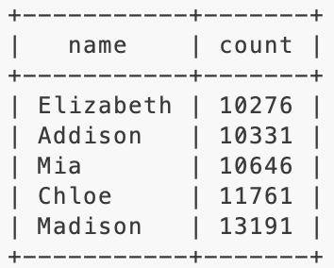

1. Step 3

* 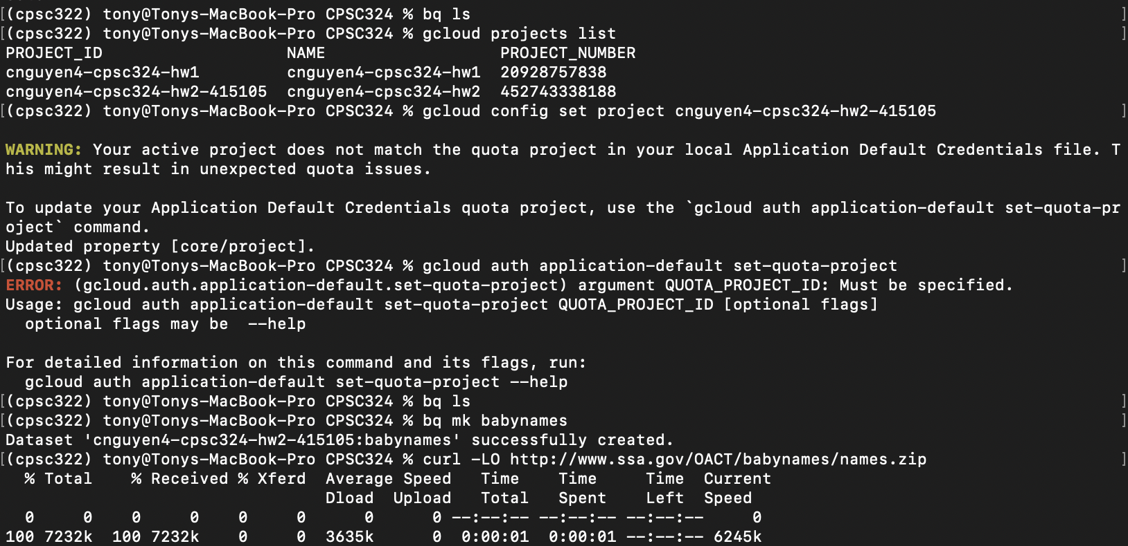
* 
* 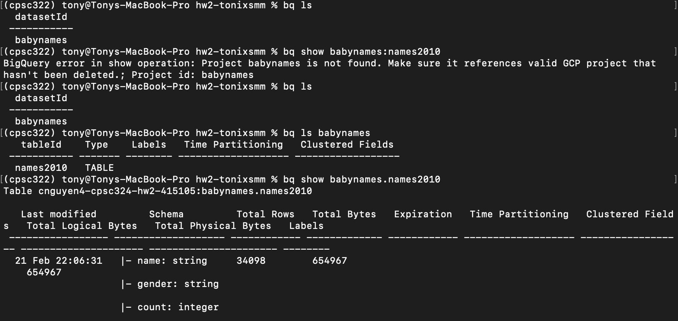

c.

* 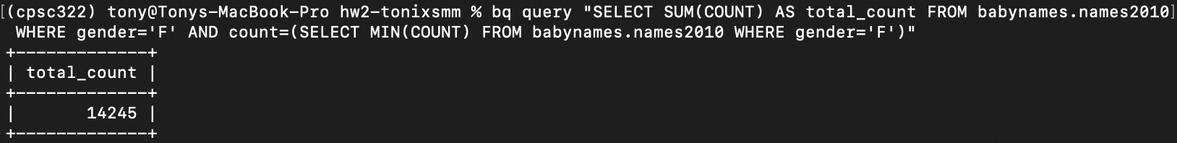

d.

* 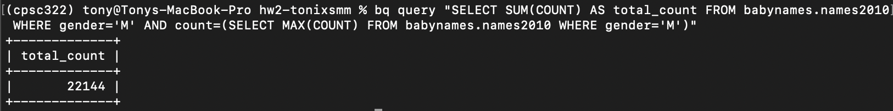

e.

* Write a query to find the total count of baby names for each gender.
* 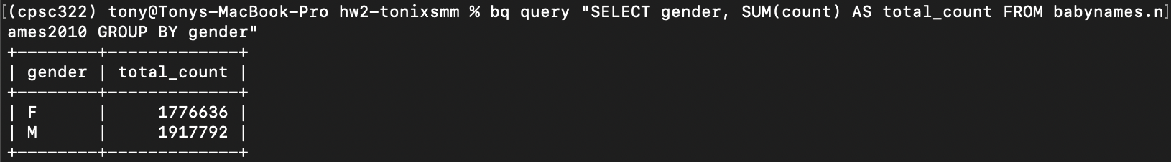

1. Step 4

* 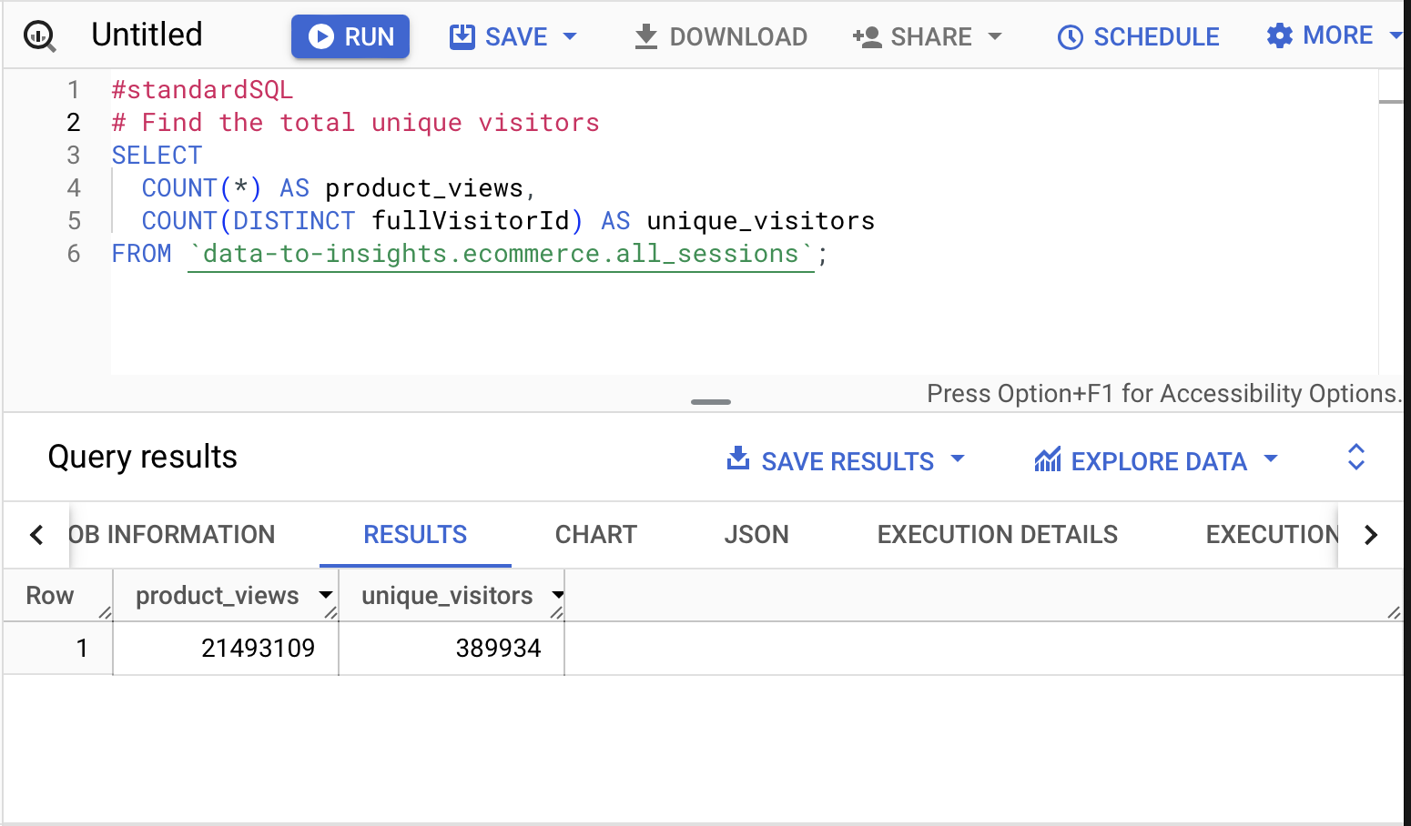
* 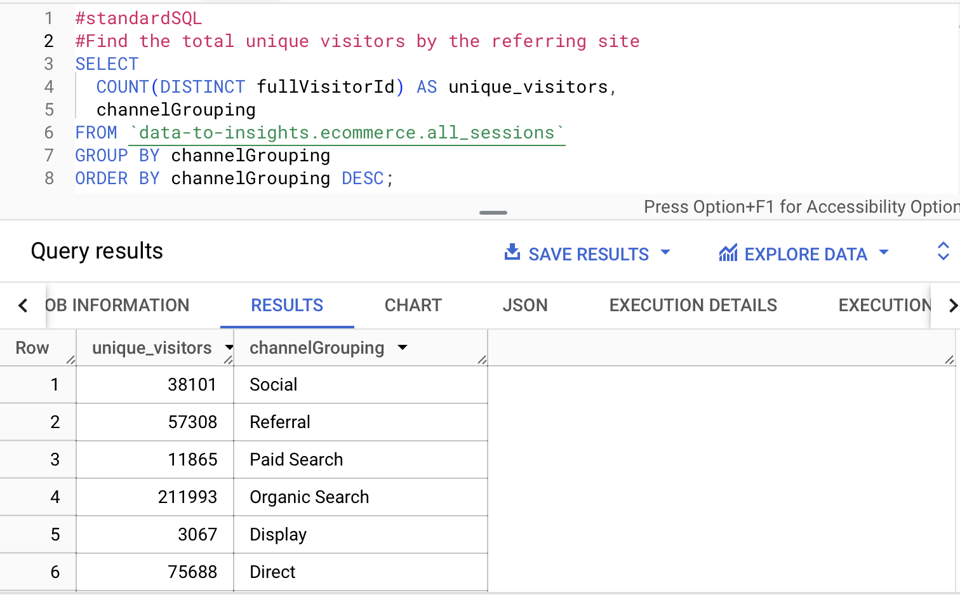
* 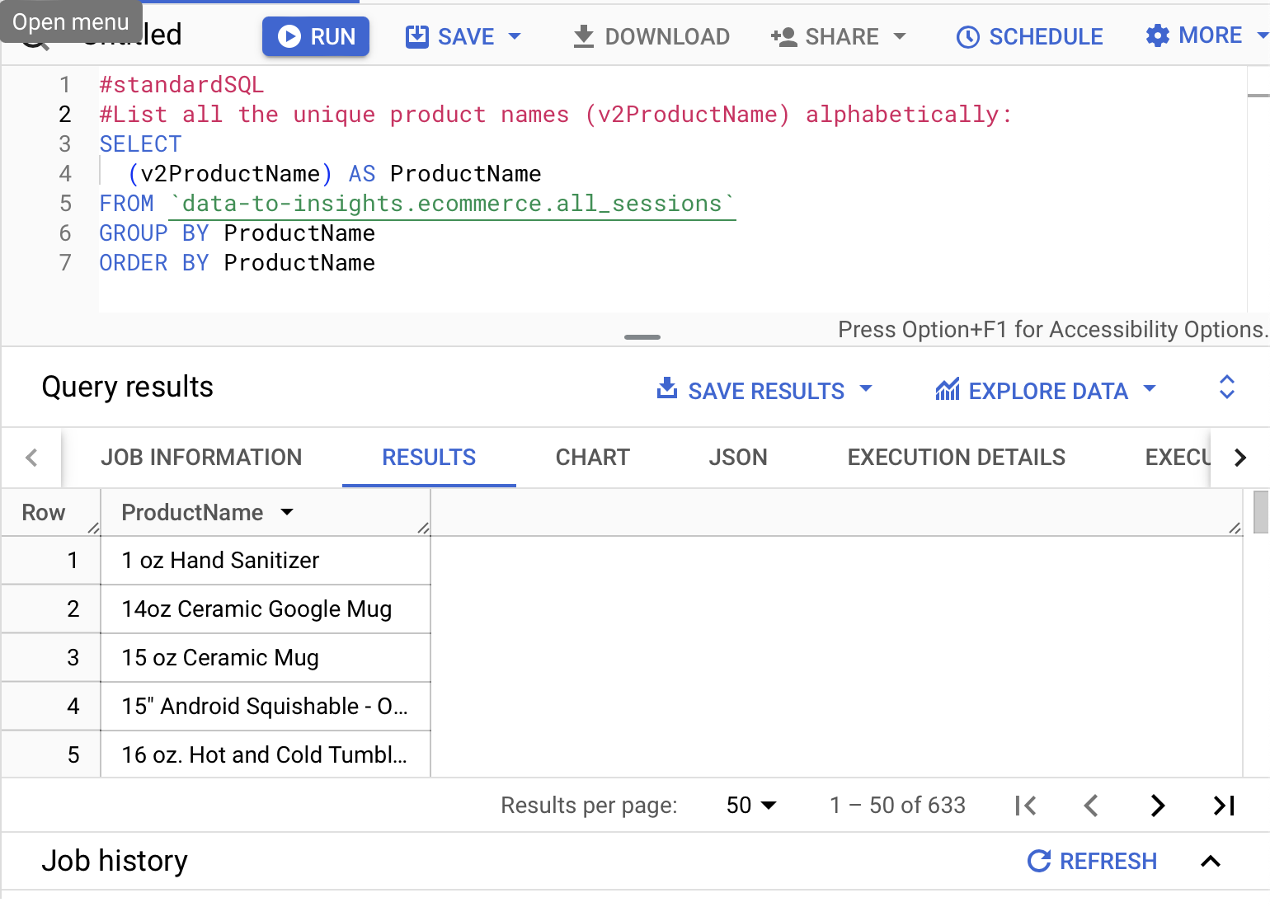
* 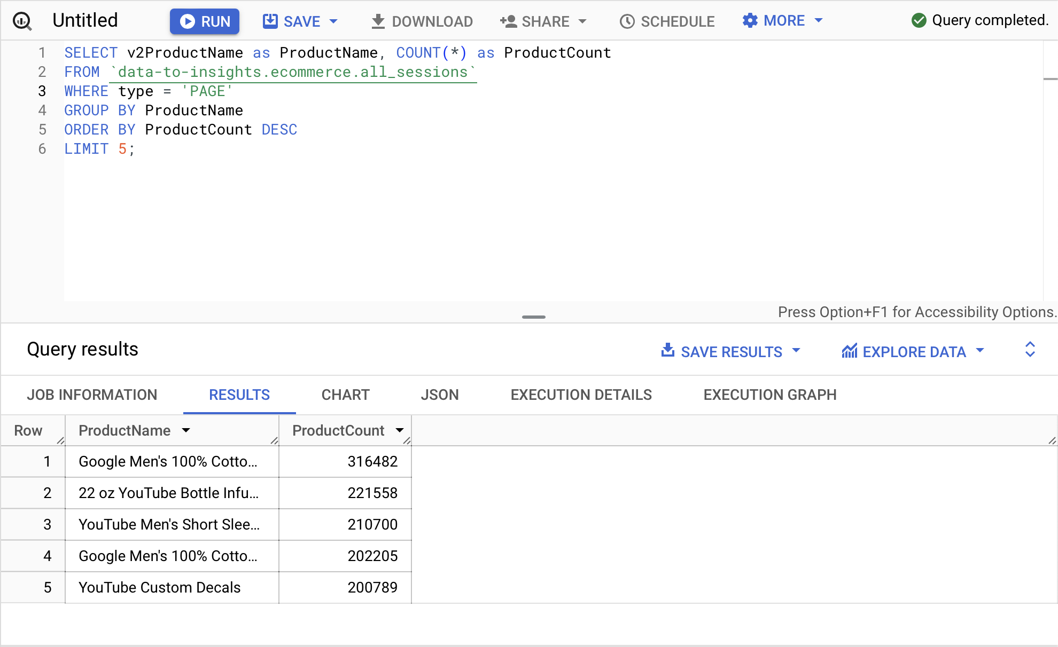
* 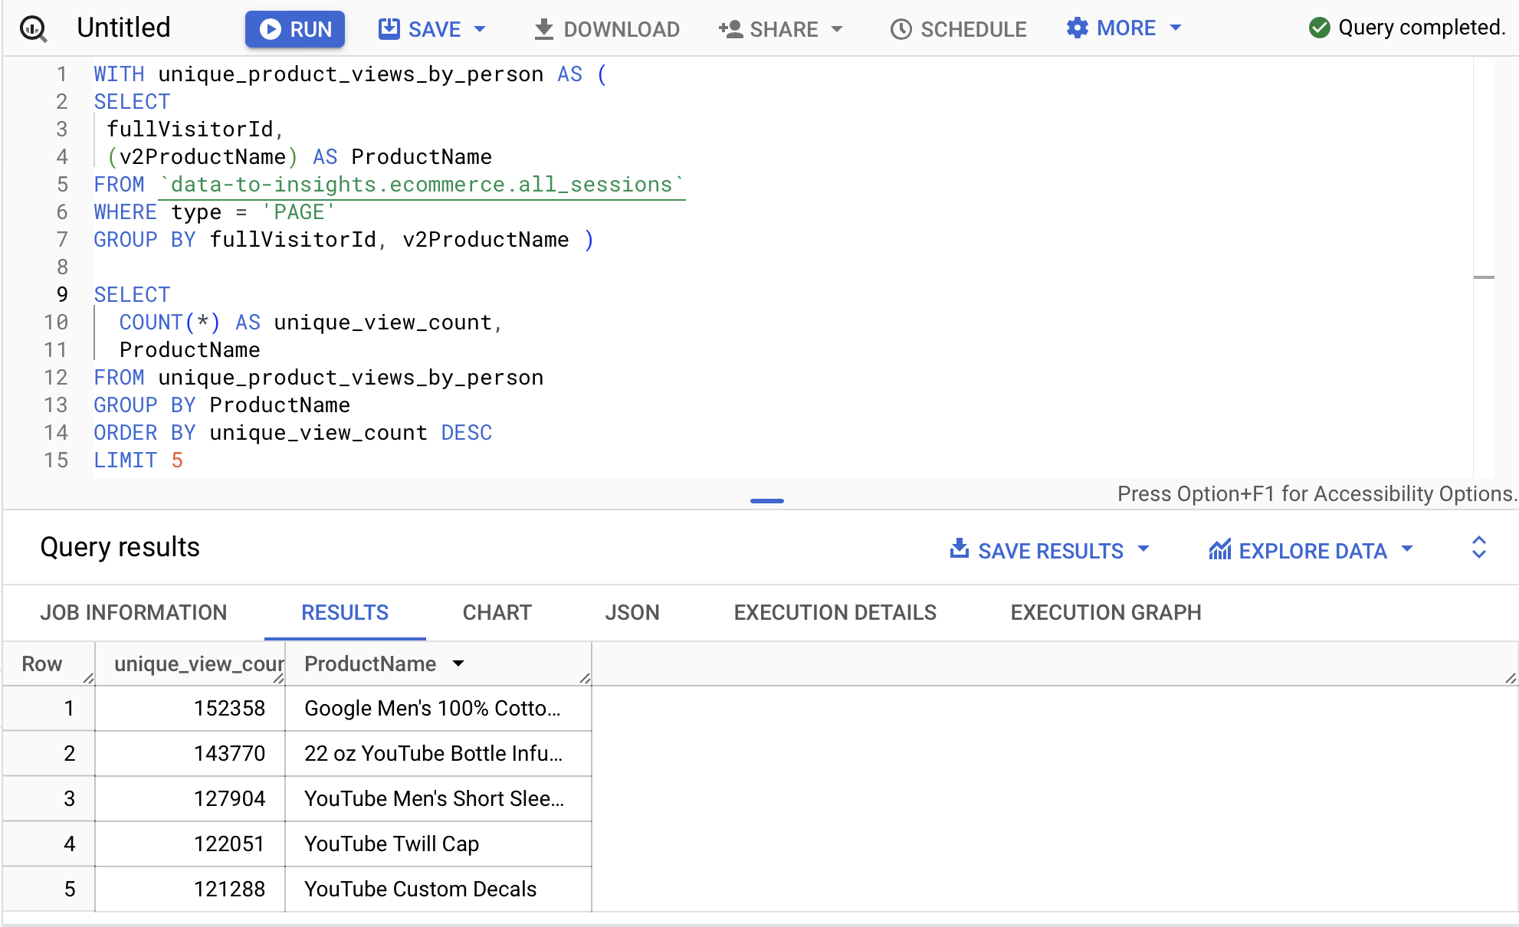
* 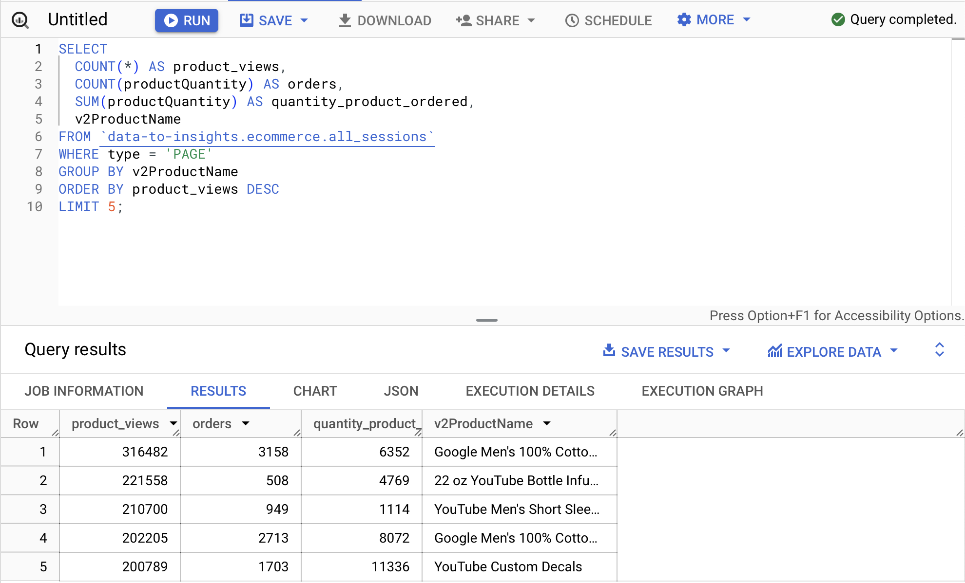
* 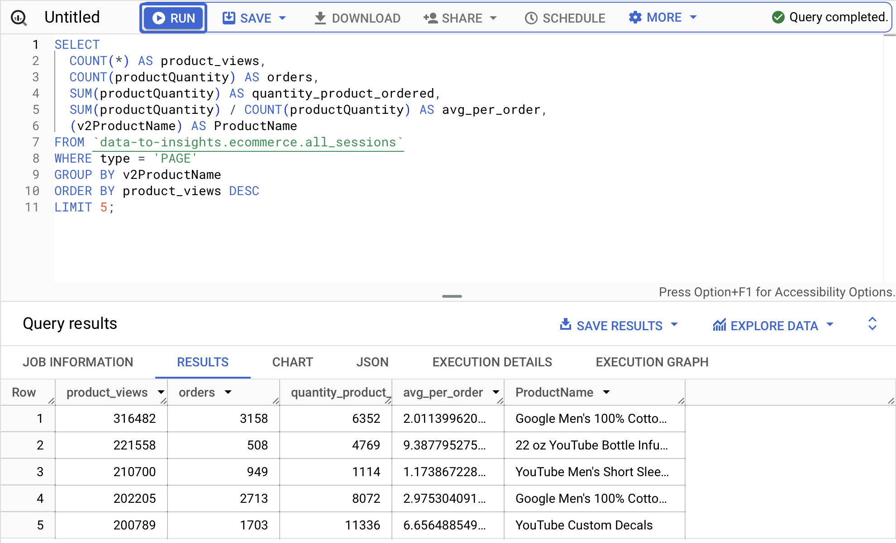
* 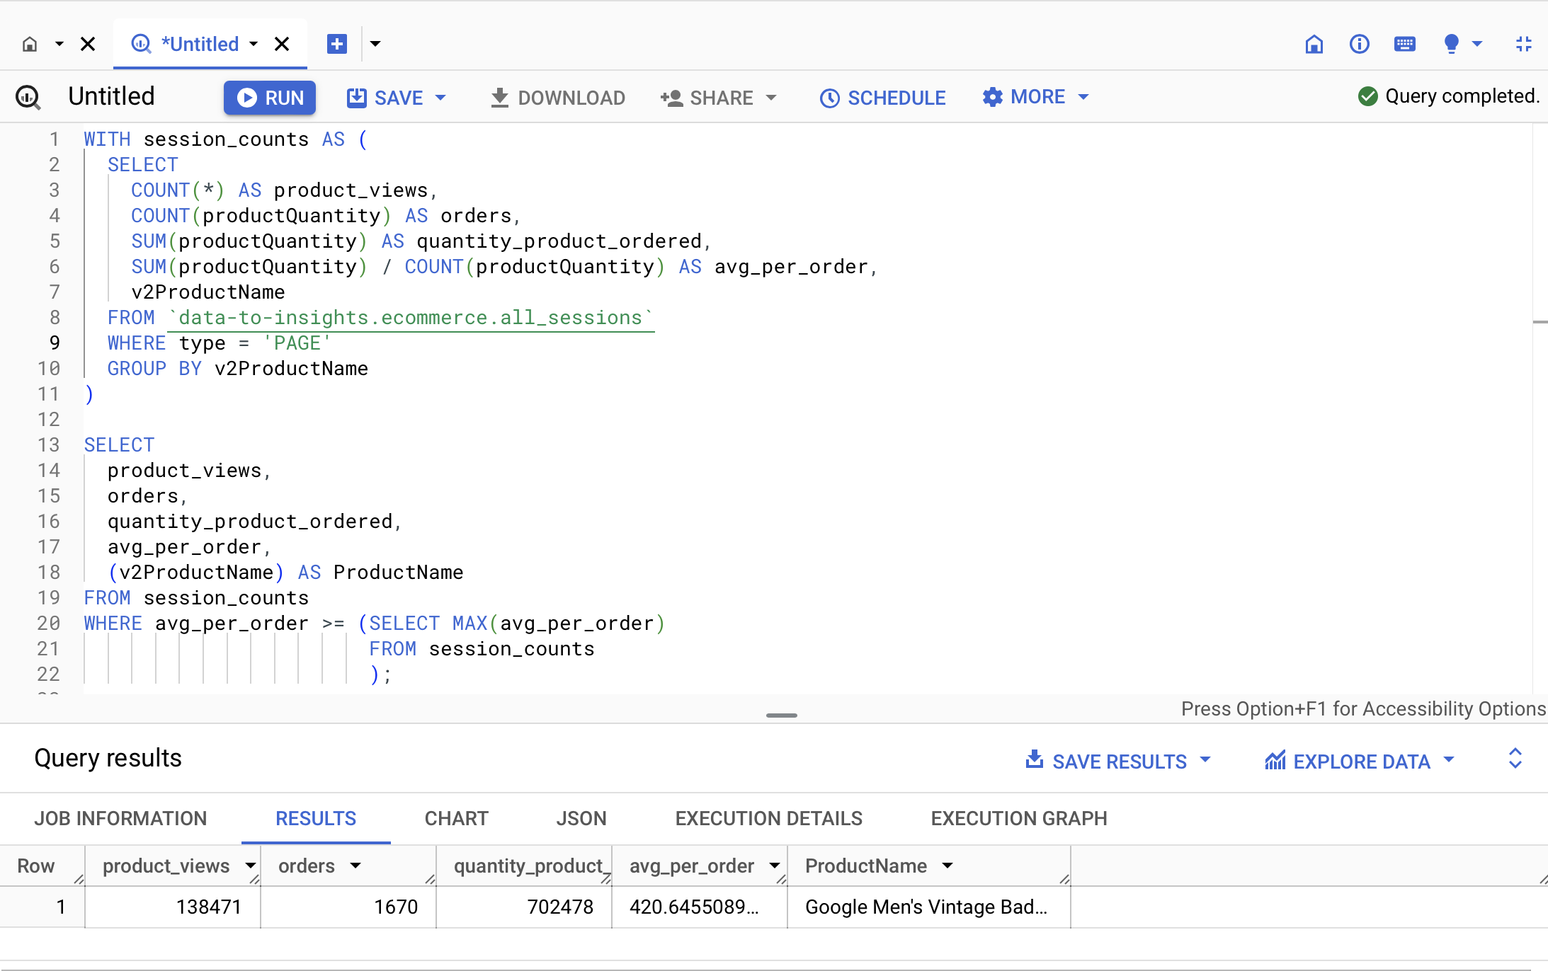
* Find the top 5 products with the highest average quantity ordered per session that have been viewed less than 100 times.
* 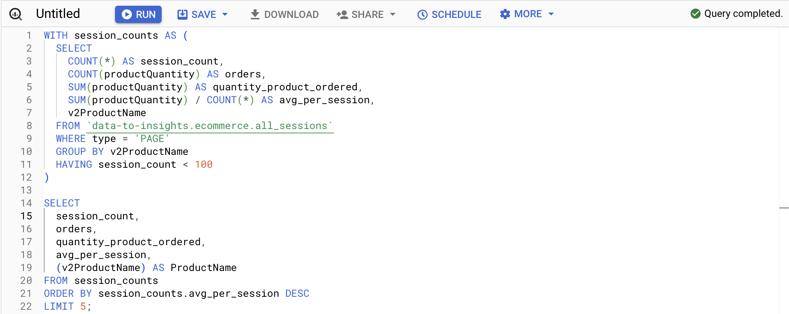
* 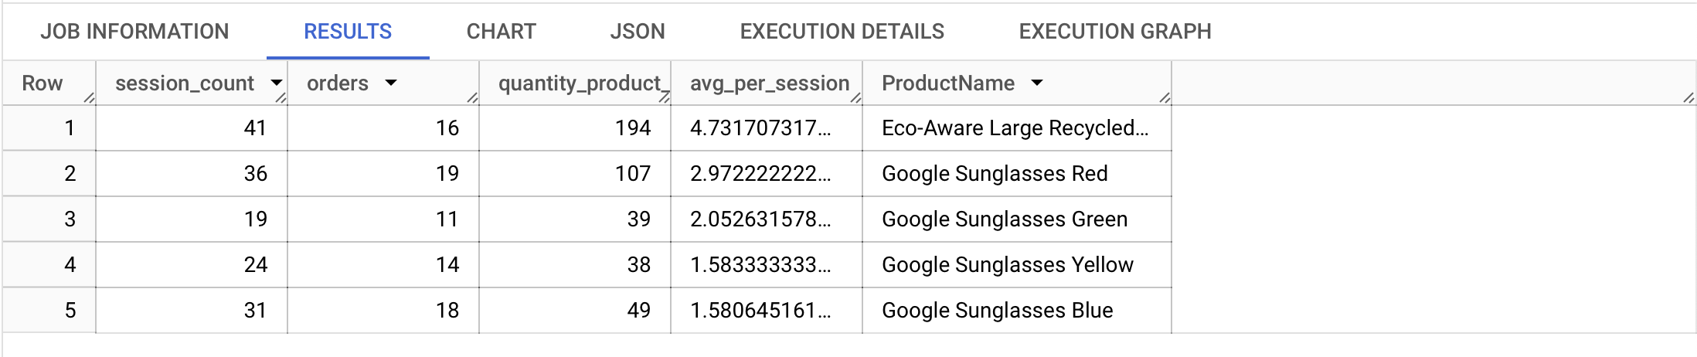

1. Step 5

* 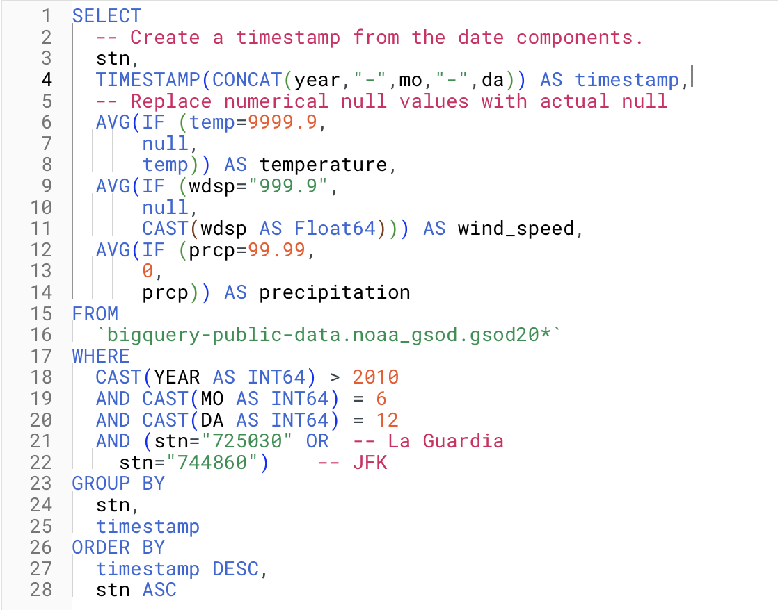
* 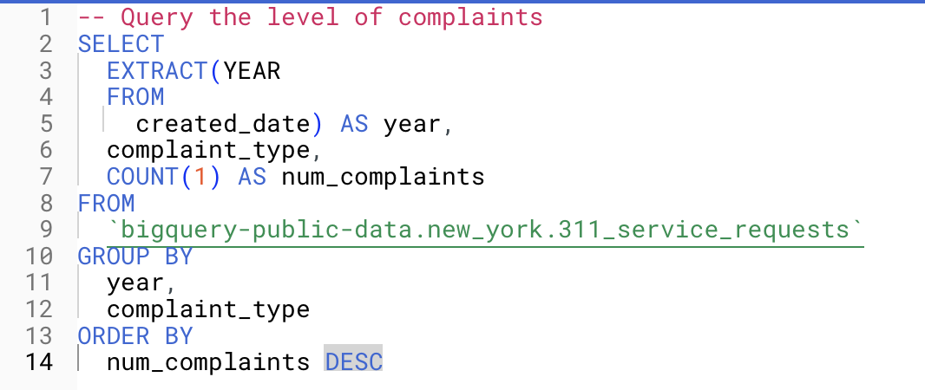
* Part 3 is trying to save a query result as a table in a dataset. By default, BigQuery returns a temporary table to show the query result. Now, such results can be saved for future uses.
* There is the IF statement, something that I have not used before
* The FROM clause seems to have a special construct of “.gsod20*” at the end,
* I guess what the FROM clause tries to do is that I query all of the files that have the beginning filename pattern to be “gsod20…”.
* The CORR function measures the correlation between two variables.
* Strong correlation is above 0.7 absolute value
* 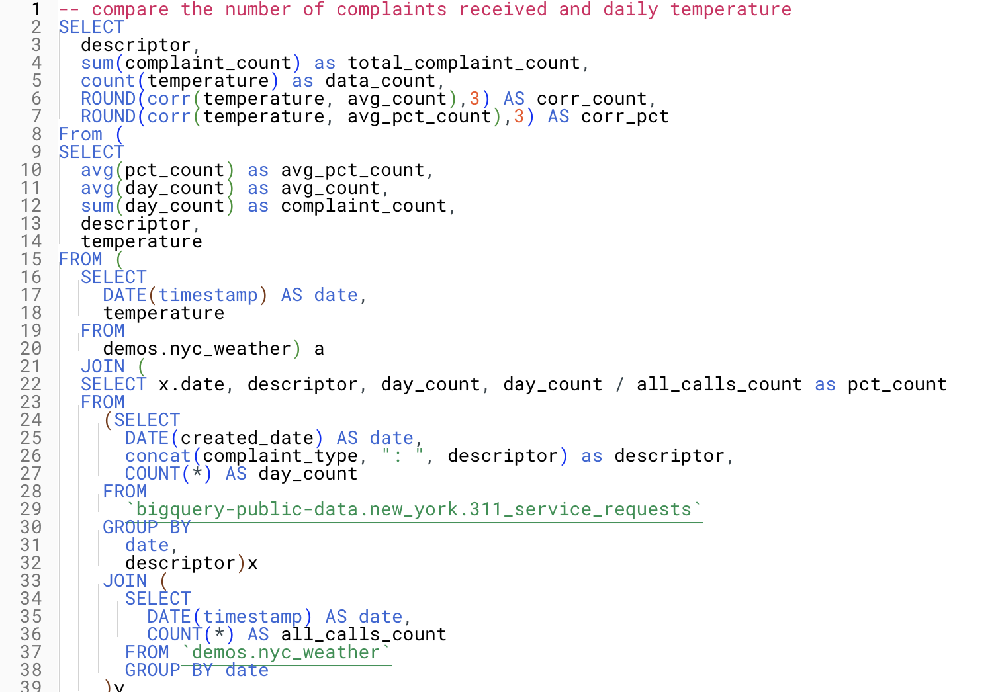
* 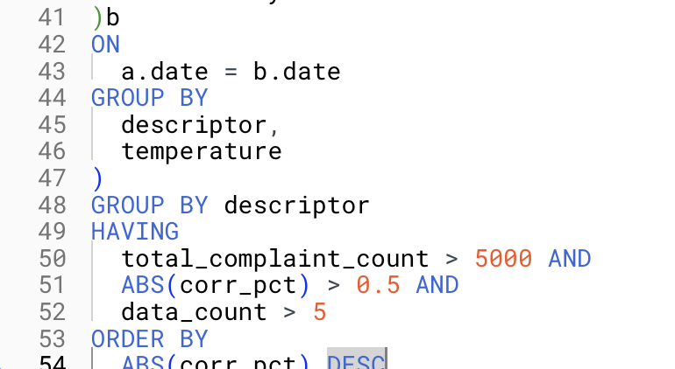
* Create a query that shows the correlation between wind_speed and precipitation in 2022
* 
* 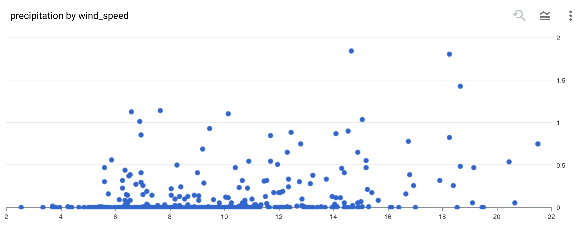

1. Step 6

* Command to append data to a current table
  + Note that it needs to be run within the same project

bq load

--source_format=CSV

--autodetect //for schema

--noreplace //append mode

nyctaxi.2018trips //destination table

gs://cloud-training/OCBL013/nyc_tlc_yellow_trips_2018_subset_2.csv //location in bucket

* Create a new table from a query

CREATE TABLE

nyctaxi.january_trips AS

SELECT *

FROM nyctaxi.2018trips

WHERE EXTRACT(Month FROM pickup_datetime)=1;

1. Step 7

* To create a dataset
  + bq --location=US mk -d hw2_dataset
* 
* 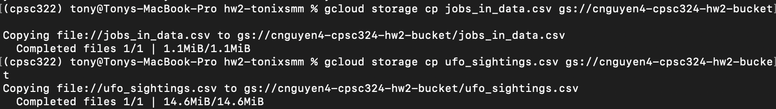
* 
* 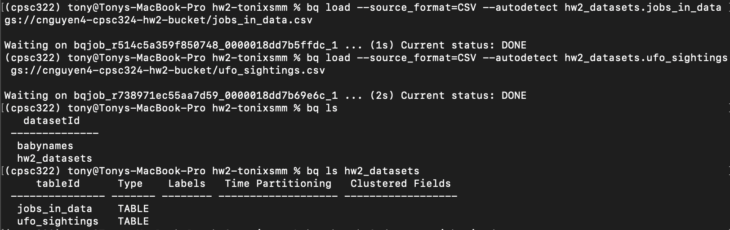
* 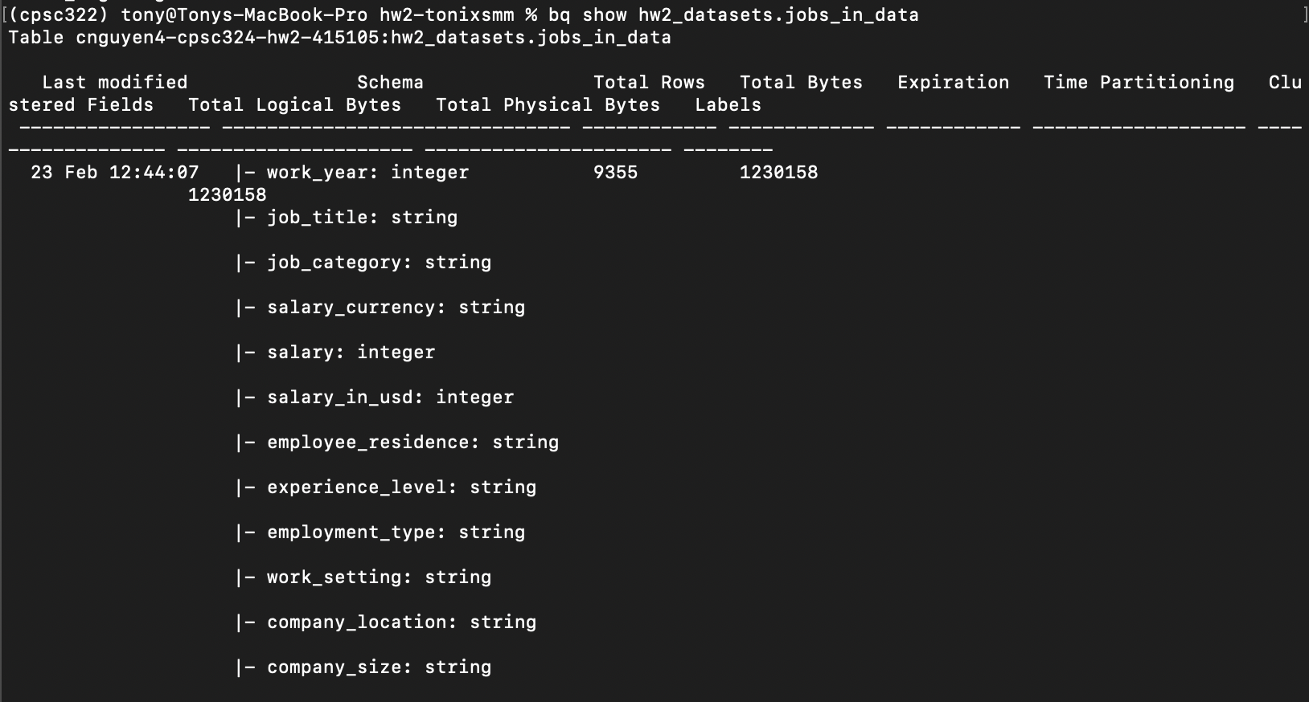
* 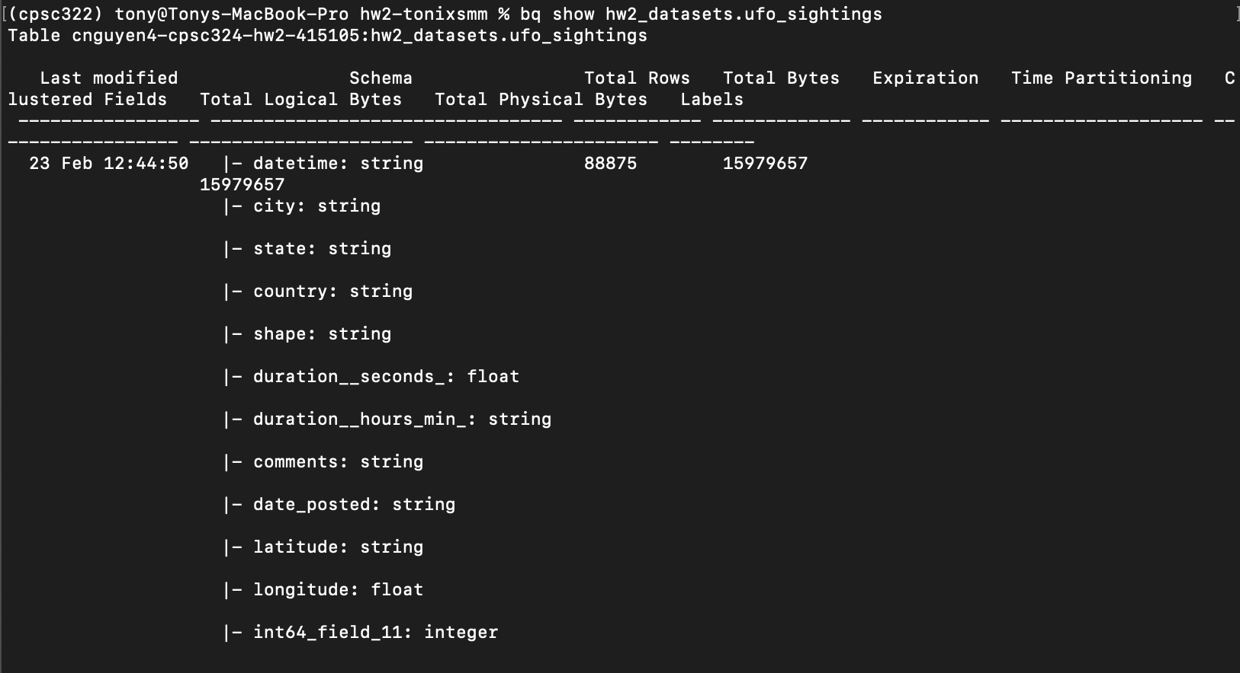
* 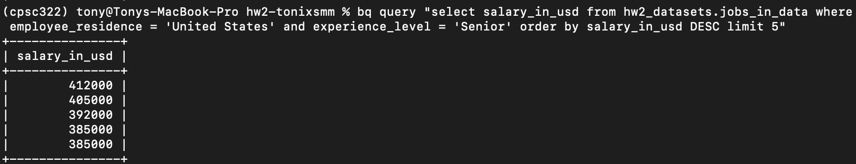
* 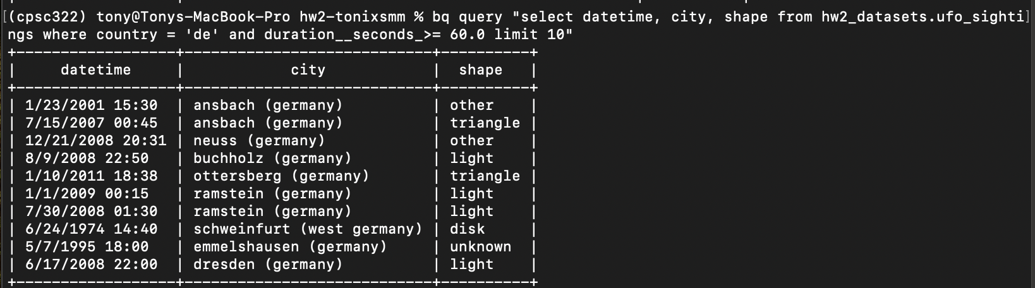

1. Step 8

* Traditional database tries to achieve the highest normalization possible.
* However, with BigQuery, we try to denormalize it to make the operation more efficient.
* Array data type
  + SELECT ['raspberry', 'blackberry', 'strawberry', 'cherry'] AS fruit_array
  + Should have the same data type for all array items
* ARRAY_AGG(): Function to aggregate our string values into an array
* SELECT fullVisitorId, date, v2ProductName, pageTitle

FROM `data-to-insights.ecommerce.all_sessions`

WHERE visitId = 1501570398

ORDER BY date

* + 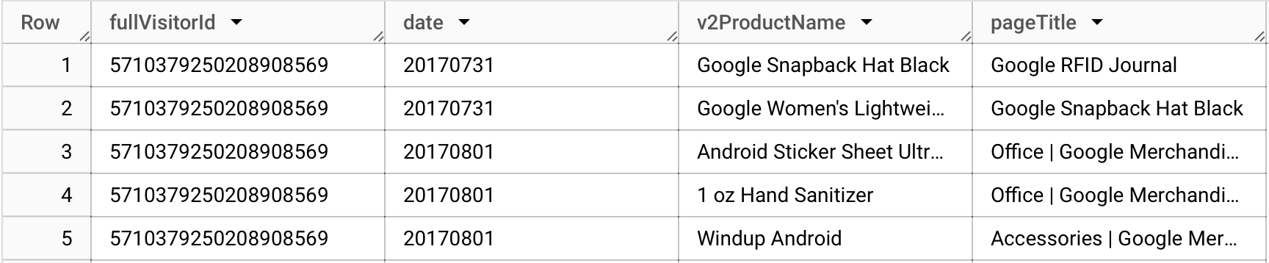
* SELECT fullVisitorId, date, ARRAY_AGG(v2ProductName) AS products_viewed, ARRAY_AGG(pageTitle) AS pages_viewed

FROM `data-to-insights.ecommerce.all_sessions`

WHERE visitId = 1501570398

GROUP BY fullVisitorId, date

ORDER BY date

* + 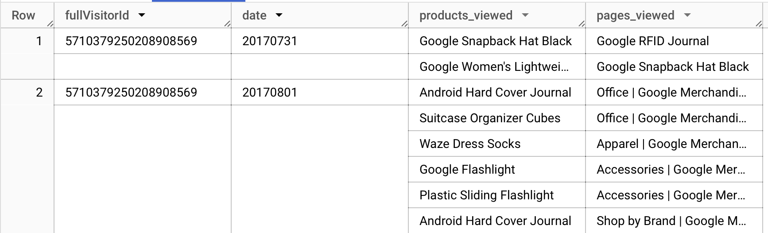
* ARRAY_LENGTH(): counts the number of pages and products that were viewed
* SELECT

fullVisitorId,

date,

ARRAY_AGG(v2ProductName) AS products_viewed,

ARRAY_LENGTH(ARRAY_AGG(v2ProductName)) AS num_products_viewed,

ARRAY_AGG(pageTitle) AS pages_viewed,

ARRAY_LENGTH(ARRAY_AGG(pageTitle)) AS num_pages_viewed

FROM `data-to-insights.ecommerce.all_sessions`

WHERE visitId = 1501570398

GROUP BY fullVisitorId, date

ORDER BY date

* + 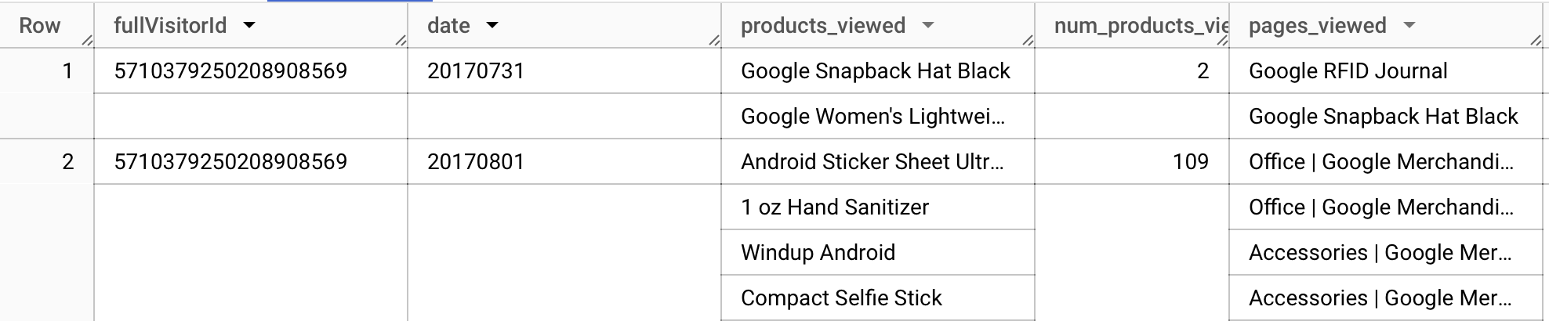
* 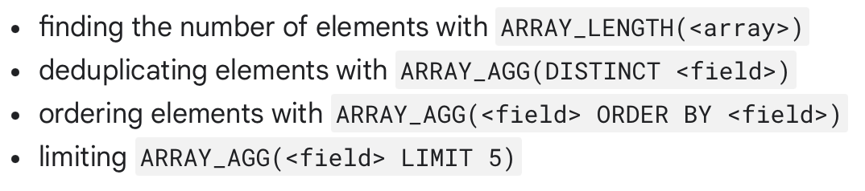
* Before we can access a repeated (type) array normally, we need to break it into rows
  + 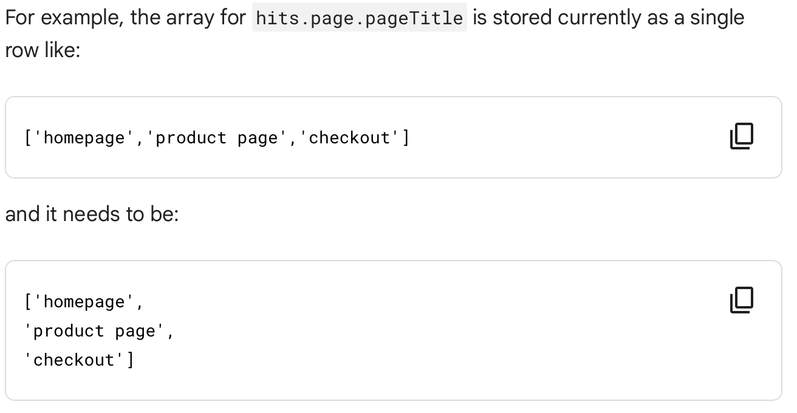
* UNNEST(): Bring the array element back into rows
  + Always follow the table name in the FROM clause
* STRUCT (RECORD data type): think of it as a separate table that is pre-joined into your main table
  + Can have:
    - One or many fields
    - Same or different data types
    - Its own alias
  + A struct can have another STRUCT as one of its field
  + totals.*,: Return all fields for that STRUCT
* SELECT STRUCT("Rudisha" as name, 23.4 as split) as runner
  + 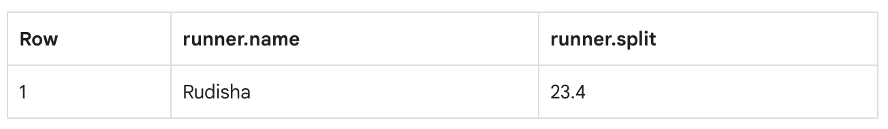
* SELECT STRUCT("Rudisha" as name, [23.4, 26.3, 26.4, 26.1] as splits) AS runner
  + 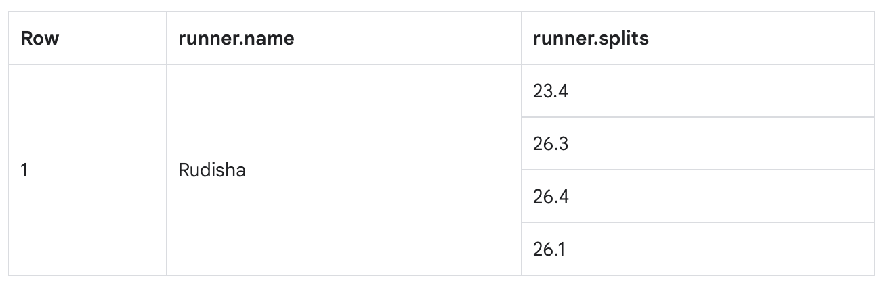
* Assuming, in this case, we need to perform a CROSS JOIN to populate the data across all fields.
  + 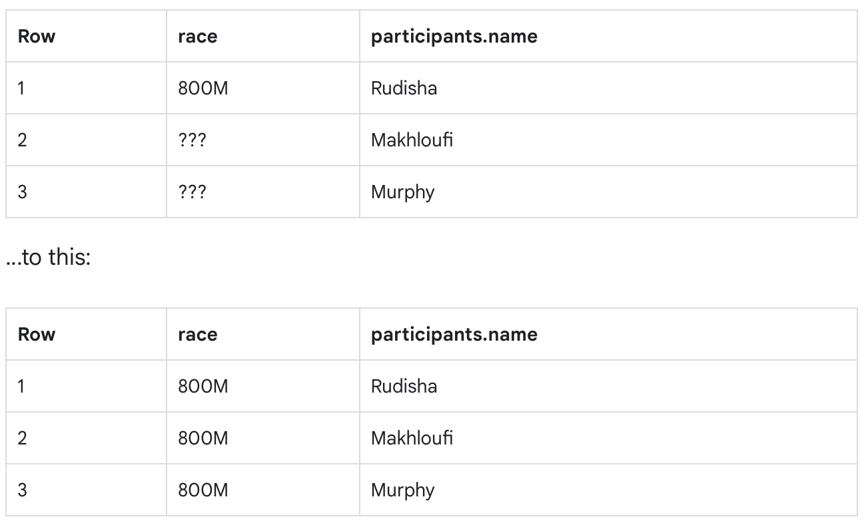
  + 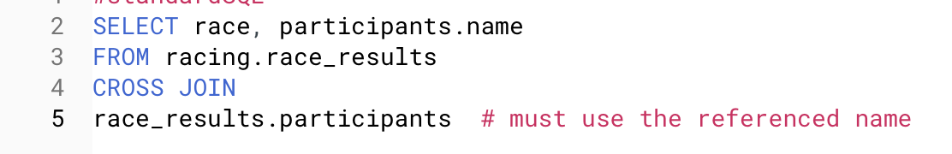
  + You can also use comma join
* 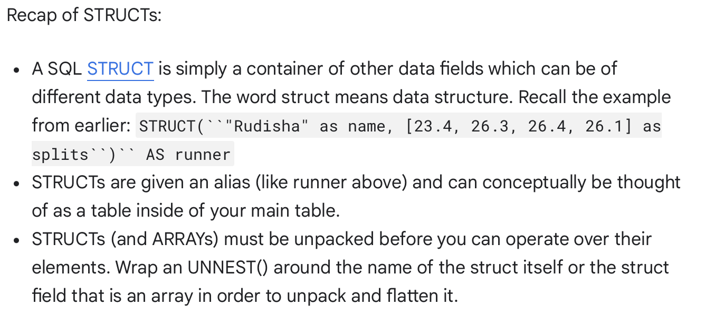
* SELECT COUNT(p.name) AS racer_count

FROM racing.race_results AS r, UNNEST(r.participants) AS p

* + Note how we need to UNNEST participant first before doing a comma join
* SELECT

p.name,

SUM(split_times) as total_race_time

FROM racing.race_results AS r, UNNEST(r.participants) AS p, UNNEST(p.splits) AS split_times

WHERE p.name LIKE 'R%'

GROUP BY p.name

ORDER BY total_race_time ASC;

* + Note the LIKE construct: find words that start with an R

c.

* Positive: arrays and structs allow us to represent more flexible data modeling since we can now represent dmore information within a single table. I also think it will give the user a friendlier look at the table since everything is grouped nicely. At the same time, it also enables us to perform more complicated queries that are faster and more efficient since fewer joint operations need to be done, which is less expensive.
* Negative: Though faster, querying a table with arrays and structs can be more challenging since we now have to deal with nested data structure, which is not initially designed to be handled by SQL. We probably have to perform additional join statements to propagate grouped data labels across their own instances. Also it also needs to factor in cost consideration when more computing powers may be needed to process the nested structure.

d.

* The NULL values mean undefined data, not necessarily missing data or empty values. In this case, an array column or its elements can be NULL.
* NULL requires special handling through functions. Because of that, developing and maintaining data structures that have NULL values is more tricky and expensive.
* NULL values in a data structure make it harder to debug in general. We have to deal with more complicated issues, not to mention data integrity.
* Besides, there is a high possibility of unexpected behaviors when performing a query, as NULL values are often treated differently by functions.

1. Step 9

* 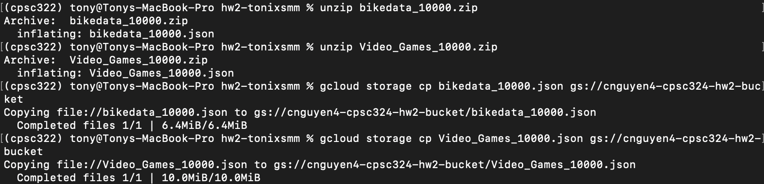
* 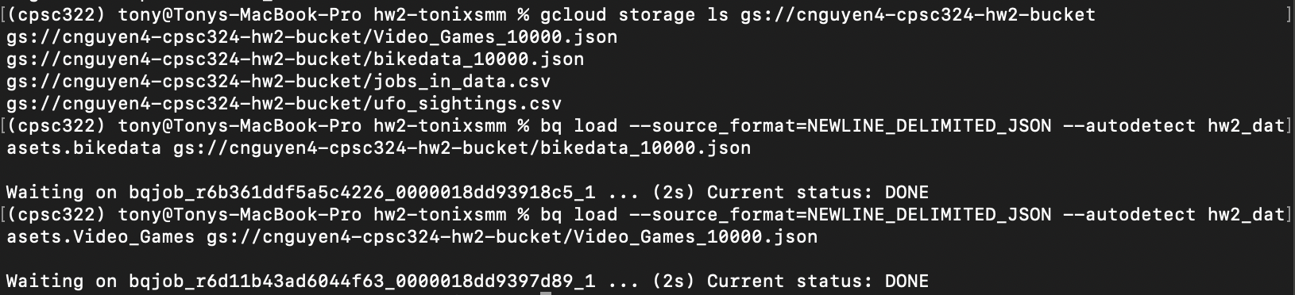
* 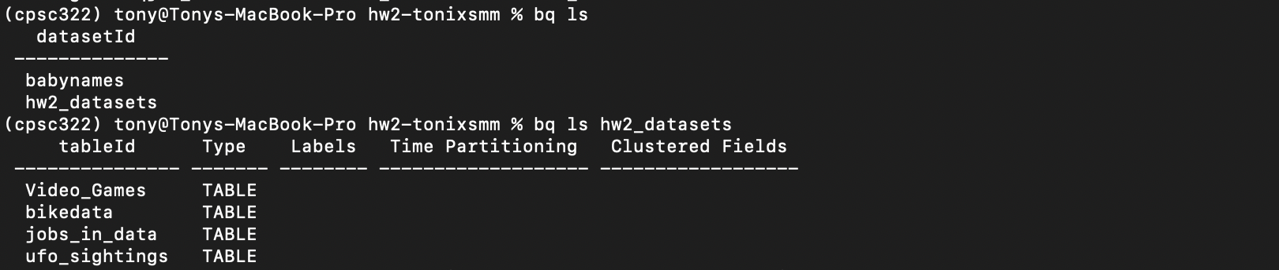

d.

* 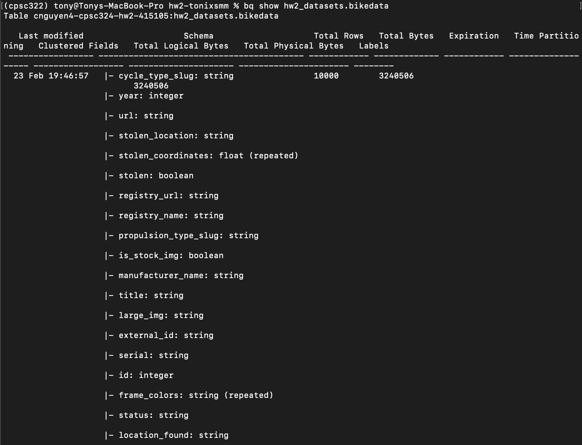
* 
* 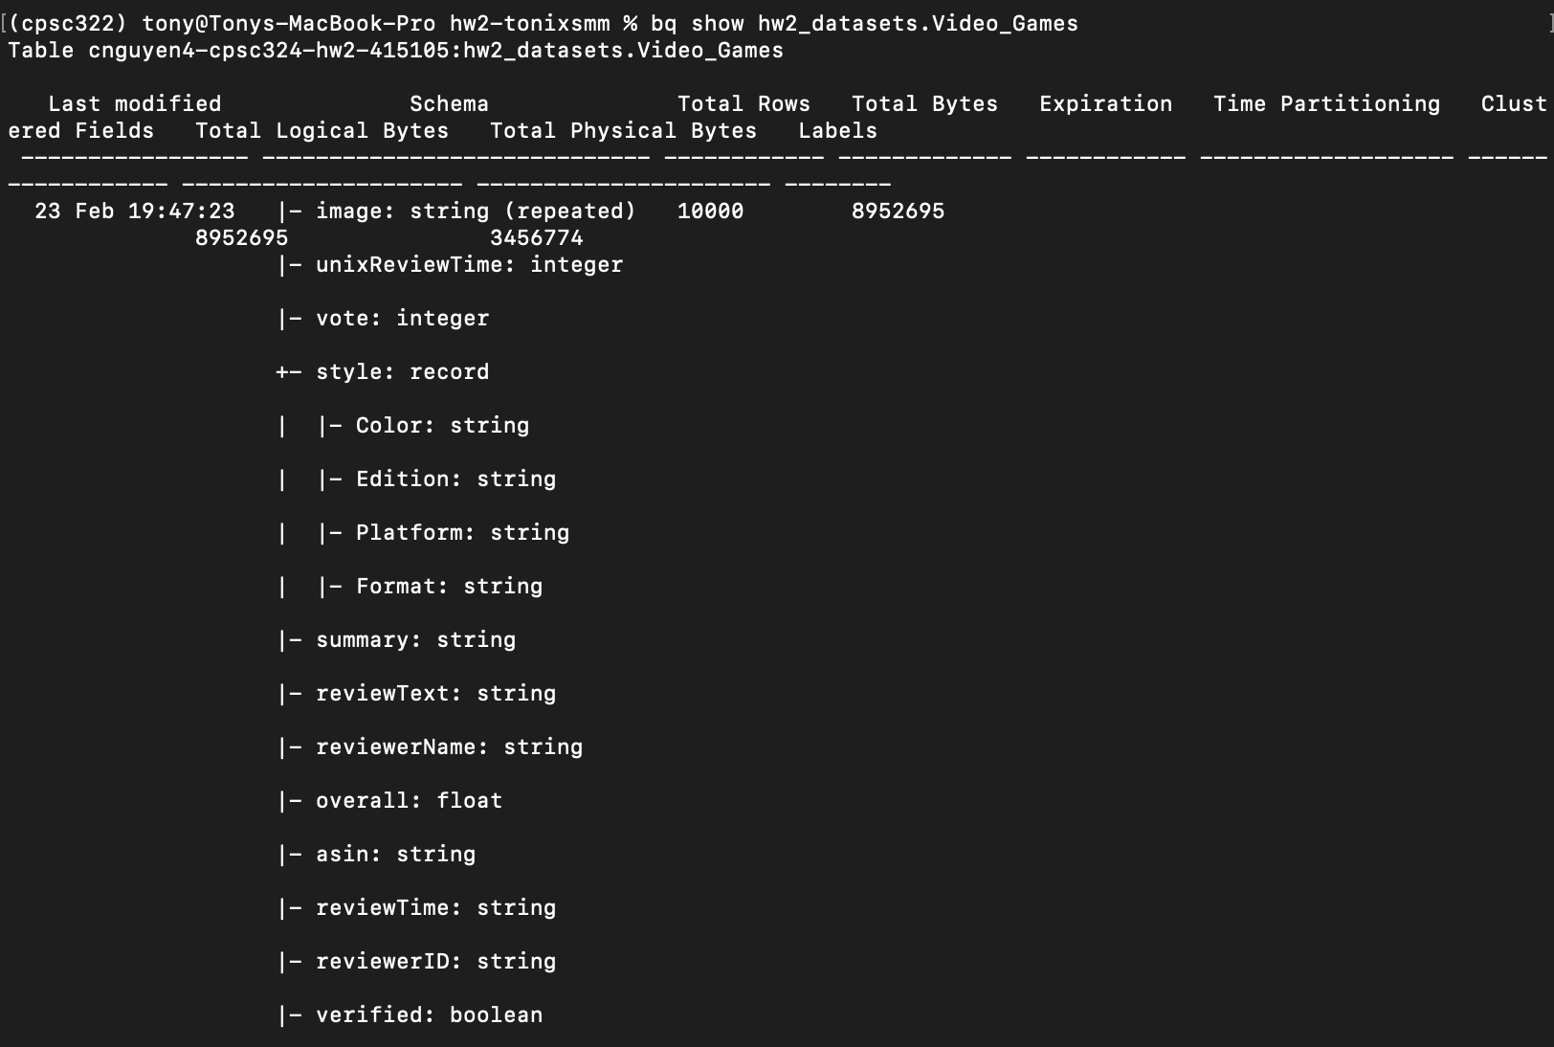
* Fields that are non-1NF (repeated or records):
  + bikedata Dataset
    - stolen_coordinates
    - frame_colors
  + Videos_Games dataset
    - image
    - style
* Bikedata Dataset
  + 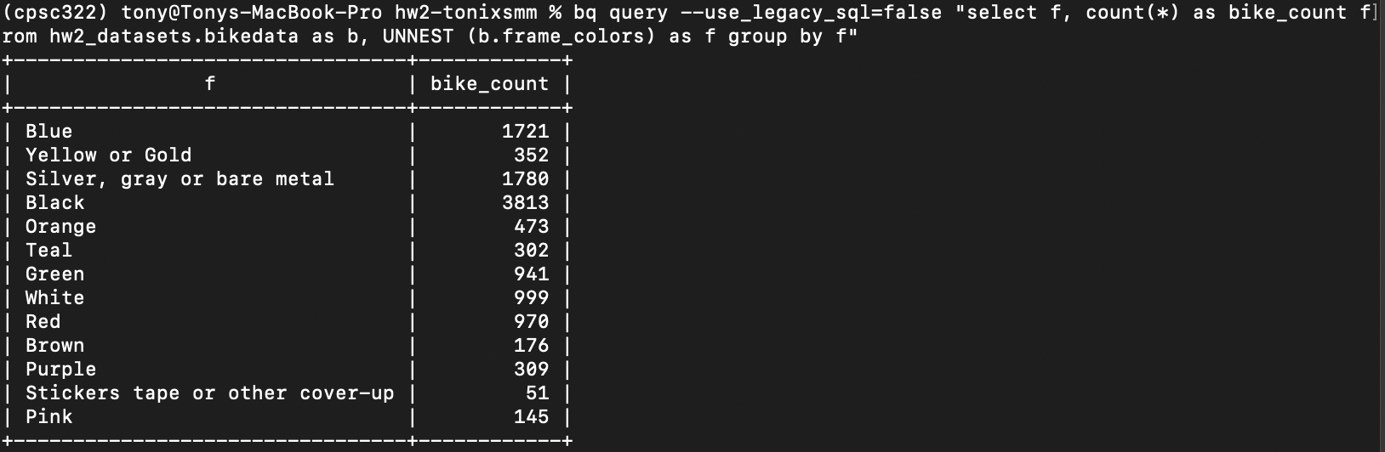
  + 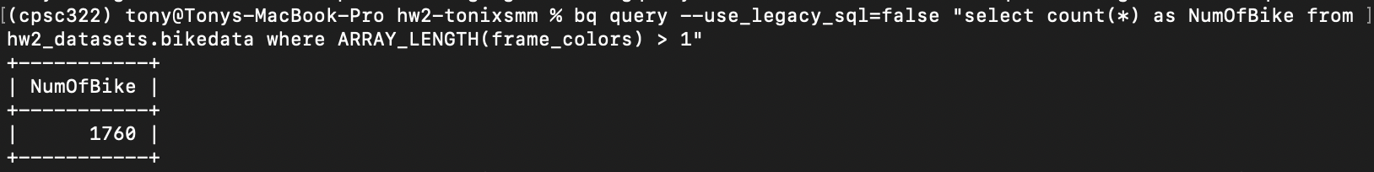
  + For some reason, it needs the –use_legacy_sql=false flag
* Video_Games dataset
  + 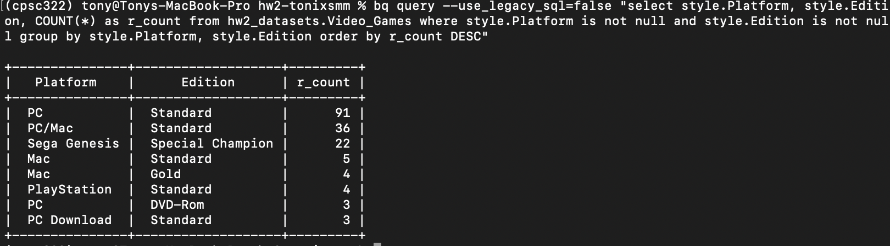
  + 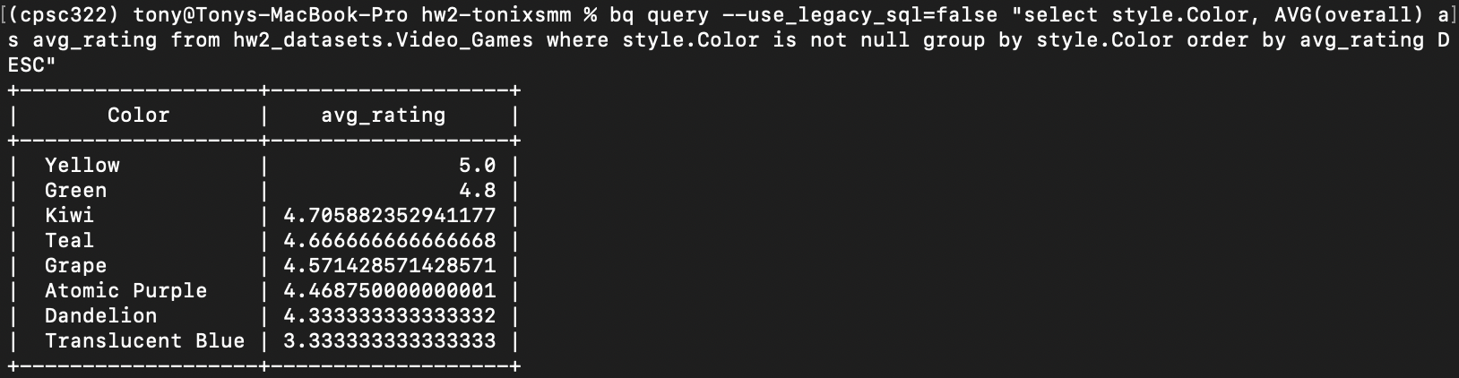

g.

* Bikedata dataset
  + 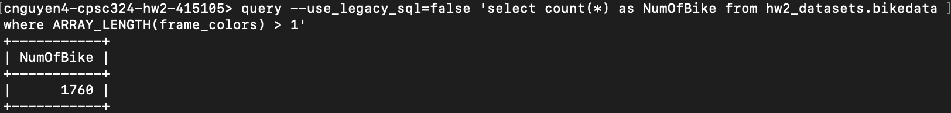
  + 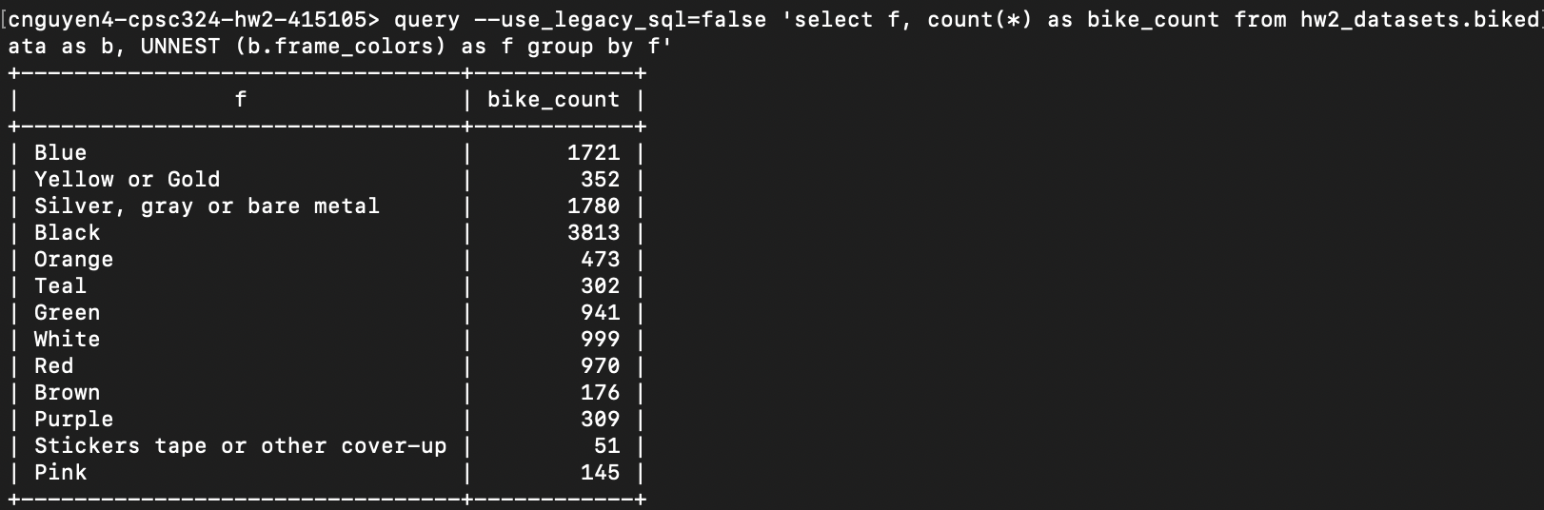
* Video_Games dataset
  + 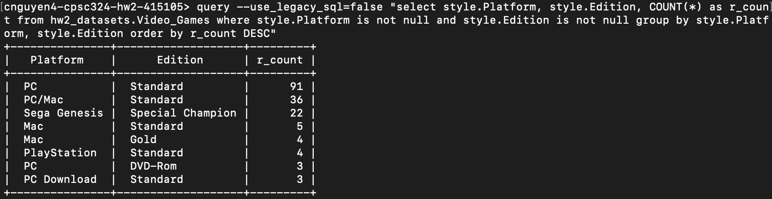
  + 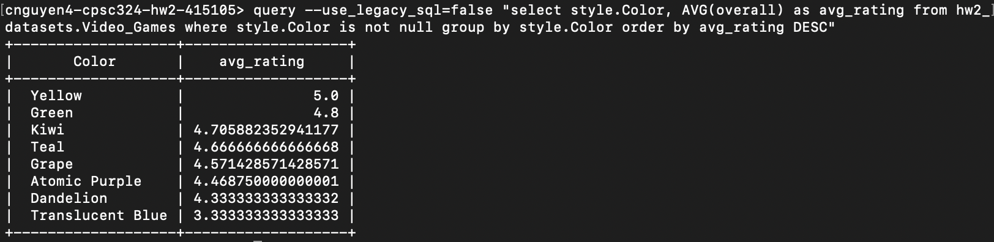

1. Step 10

* 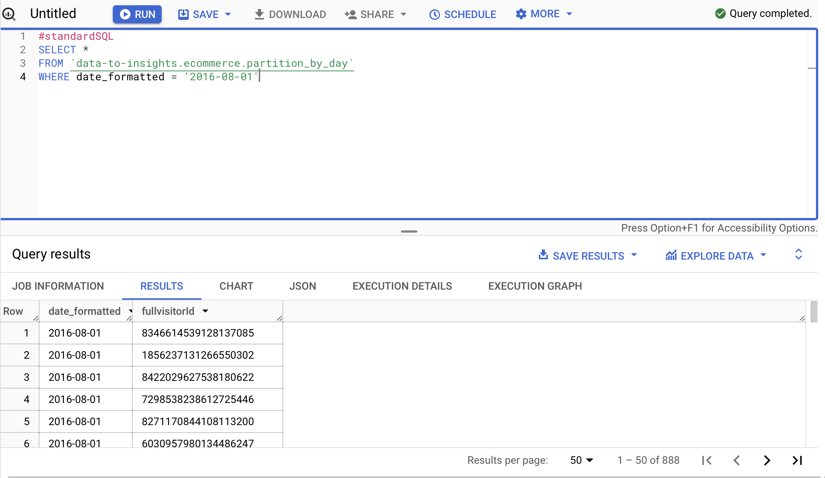
* 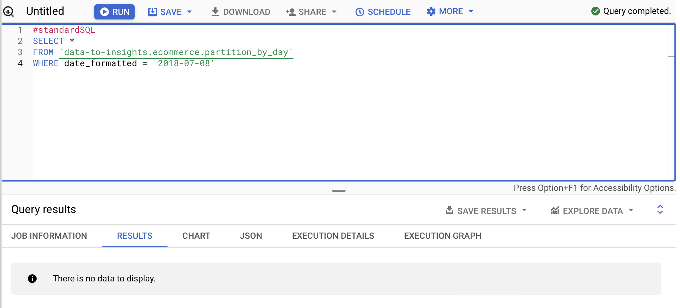

1. Notes

* We create a partition table in order to divide our original data into smaller partitions, which can be used to query against. It makes it easier, faster, and more efficient to query as we don’t have to scan through the whole table anymore. It also reduces costs.
* 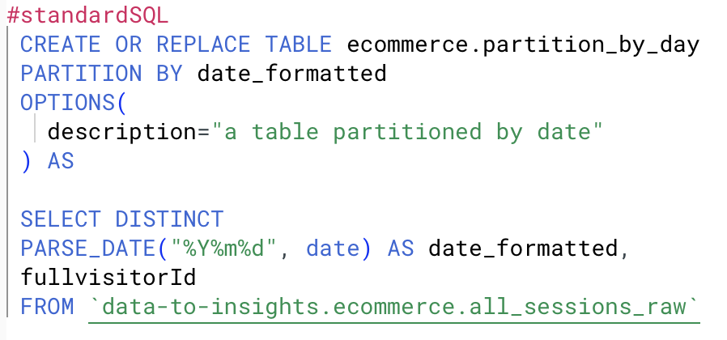
  + Note that the Partition By function has two options
    - Date_formatted
    - Timestamp
  + PARSE_DATE function: get the proper DATE type for partitioning
* 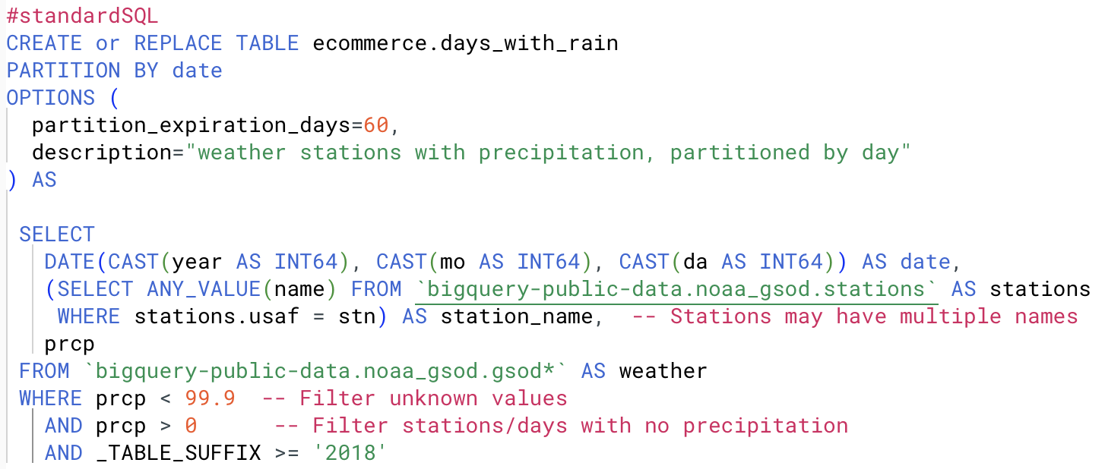
* Query to check when did this data table is stored
  + 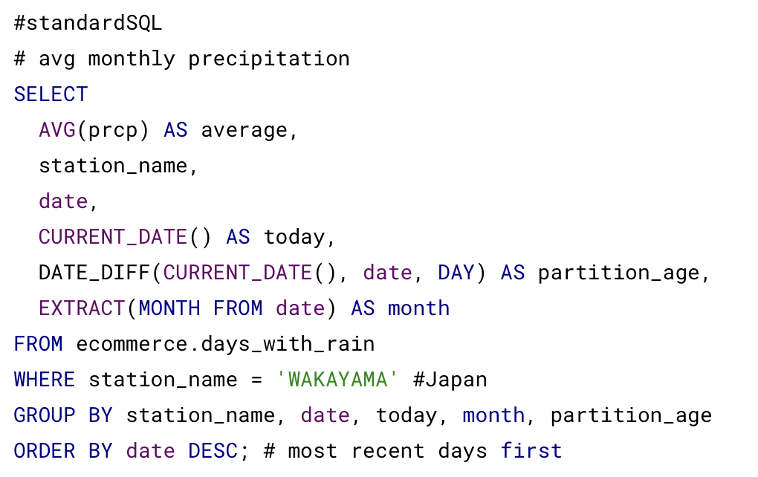

1. Step 11

* 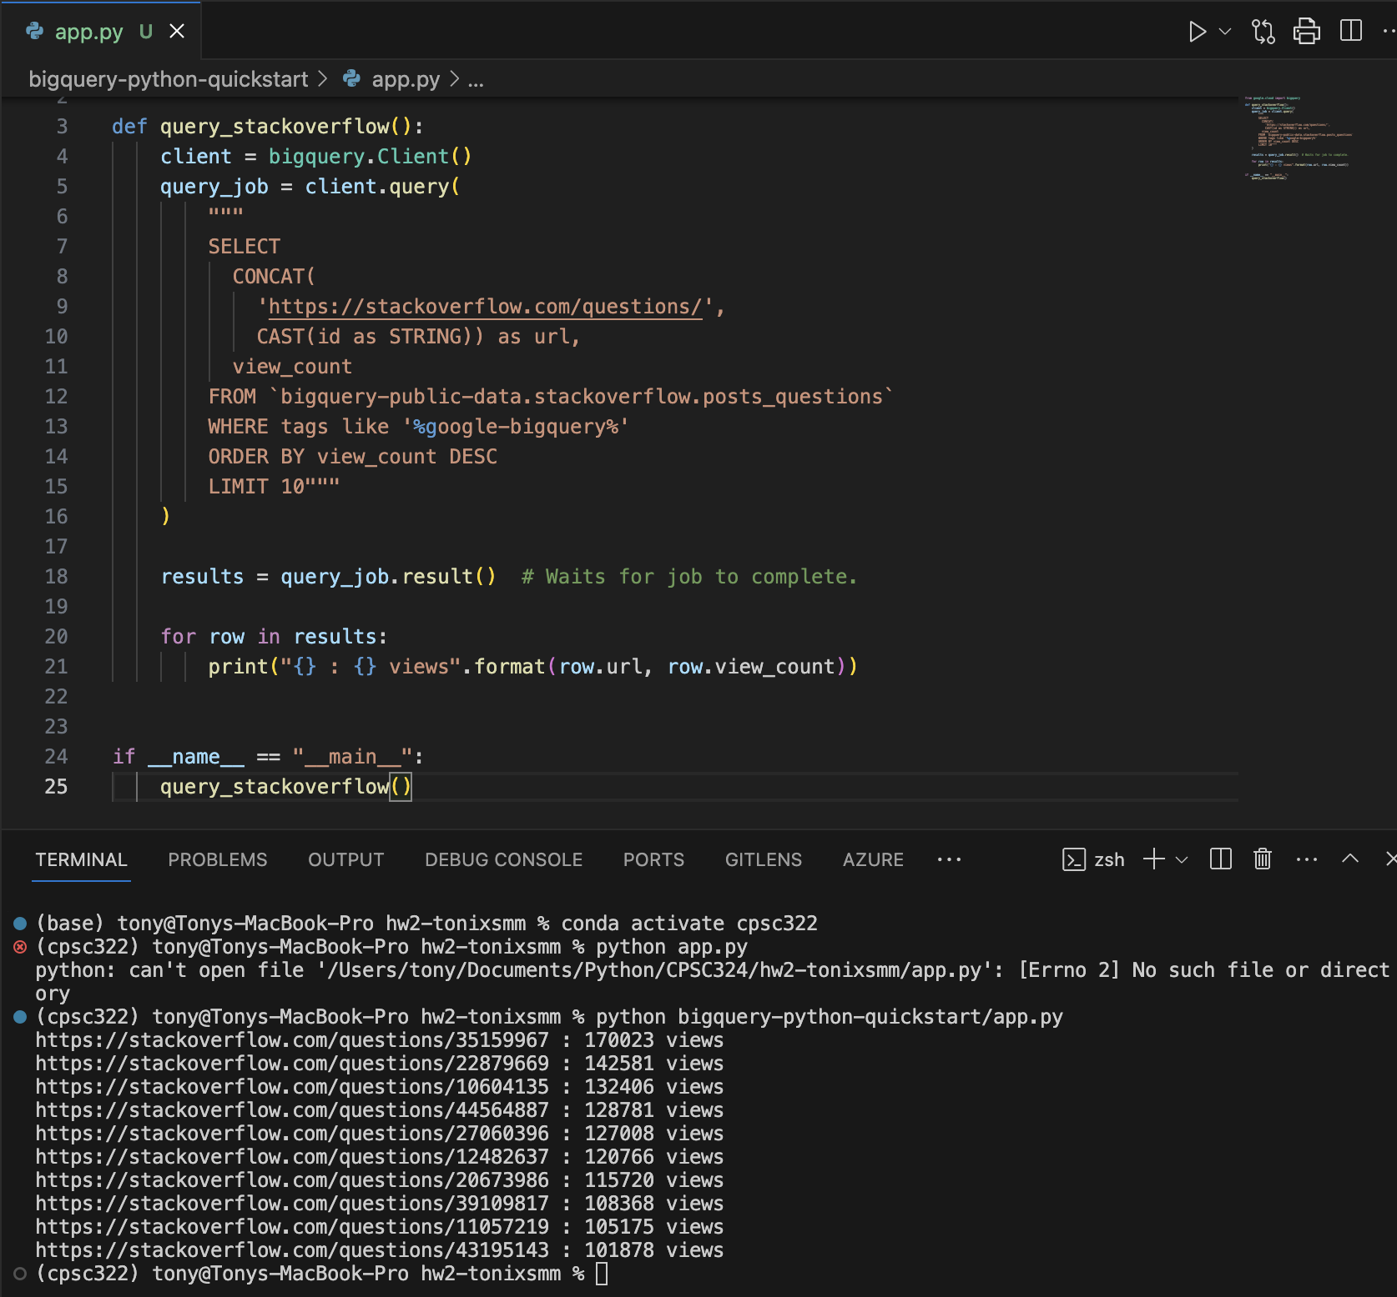

1. Step 12

* 
 